**11**

**Angular Momentum**

|  |
| --- |
| **CHAPTER OUTLINE** |

11.1 The Vector Product and Torque

11.2 Analysis Model: Nonisolated System (Angular Momentum)

11.3 Angular Momentum of a Rotating Rigid Object

11.4 Analysis Model: Isolated System (Angular Momentum)

11.5 The Motion of Gyroscopes and Tops

\* An asterisk indicates a question or problem new to this edition.

|  |
| --- |
| **SOLUTIONS TO THINK-PAIR-SHARE AND ACTIVITIES** |

**\*TP11.1** The keys begin to fall downward and the binder clip begins to swing downward like a pendulum. As the keys fall straight down, the length of string from the pencil to the binder clip decreases. If we temporarily ignore gravity, as the radius of the path of the clip decreases conservation of angular momentum about an axis through the pencil would require that its speed increase. As a result, the binder clip moves very rapidly and the length of string connected to the binder clip will eventually wrap itself several times around the pencil, where there is enough friction force between the string and the pencil to stop the downward motion of the keys, and they end up suspended from the string. Now, what about gravity? Because of the torque on the clip due to the gravitational force, the binder clip is *not* an isolated system and angular momentum is *not* conserved. However, the gravitational force causes the angular speed to increase even faster as the binder clip initially swings downward, so it makes the effect work even better! While angular momentum for the clip is not strictly conserved, the increase in speed as the radius of the path decreases does indeed occur.

**\*TP11.2 Conceptualize** Imagine the process illustrated in the figure. As the upper disk lands on the lower disk, the upper disk speeds up and the lower disk slows down until they rotate at the same angular speed. This is a rotational version of a perfectly inelastic collision.

**Categorize** The system of two disks is modeled as an *isolated system* for *angular momentum.*

**Analyze** (a) Begin with Equation 11.19:

 (1)

Solve for *f*:

 (2)

(b) Set up the requested ratio of energies:

 (3)

Substitute Equation (2) into Equation (3):

 (4)

(c) (i) From Equation (4), if *I*2 → 0, .

(ii) From Equation (4), if *I*1 = *I*2, .

(iii) From Equation (4), if *I*2 → ∞, .

(iv) From Equation (4), if *I*1 → ∞, .

(d) Let us look at each limit in turn:

(i) If *I*2 → 0, then the upper disk has no moment of inertia and should have no effect when it falls onto the lower disk. This is indicated by the fraction of 1: the final kinetic energy is the same as the initial.

(ii) If *I*1 = *I*2, then the upper disk is dynamically equivalent to the lower disk. By symmetry, we could argue that half of the initial kinetic energy will be transformed or transferred away in this case.

(iii) If *I*2 → ∞, the upper disk is far more massive than the lower disk. When the upper disk falls, it simply overwhelms the initially rotating lower disk and brings it to a stop. The final kinetic energy is zero.

(iv) If *I*1 → ∞, the lower disk is far more massive than the upper disk. Therefore, the effect of the falling upper disk is minimal and there is no change in the energy of the system.

(e) The primary change is from kinetic energy to internal energy in the system: the disks are warmer after the collision. (This will be followed by transfer of energy by heat into the cooler surrounding air.) A small amount of energy will leave the system by sound when the upper disk strikes the lower disk.

(f) We alter Equation (1) to account for the initial rotation of the second disk:

 (7)

Solve for the final angular speed:

 (5)

Comparing Equation (5) to Equation (2), we see that the final angular speed will be smaller, as we might have expected.

**Finalize** Before music was recorded on CDs or available digitally, it was recorded on vinyl records. *Record changers* were devices that would allow a stack of records to be suspended over a rotating turntable. When one record was finished, another record would drop downward on the stack of previously played records on the turntable. This collision is similar to that in Figure TP11.2, except for the fact that the turntable was not freely rotating. It was driven by a motor, to bring the newly dropped record up to the proper playing speed. Finally, looking at part (f), the final angular speed could be zero if



Answers: (a)  (b)  (c) (i) 1 (ii)  (iii) 0 (iv) 1 (d) Answers will vary. (e) internal energy, sound (f) 

**\*TP11.3 Conceptualize** Figure TP11.3 shows the physical setup of the carnival game. When the ball collides with the rod and sticks to it, the rod­–ball combination will rotate counterclockwise. The goal is to have the rod reach a position 180° opposite to where it begins.

**Categorize** The collision of the ball and the rod can be analyzed with the *isolated system* for *angular momentum* model . After the collision, the *isolated system* for *energy* model can be used to analyze the swinging upward of the combined rod and stick.

**Analyze** (a) Assume the ball strikes the rod at a distance *y* from its upper end as shown in Figure TP11.3. Apply the isolated system model for angular momentum to the ball–rod system, with the initial instant just before the collision and the final instant just after, and taking all angular momenta around the pivot point of the rod:

 (1)

where ** is the angular speed of the system just after the collision. Apply the isolated system model for energy to the ball–rod system, with the initial instant just after the collision and the final instant as the rod reaches its highest vertical position and just comes to rest. This choice will provide the minimum speed with which the ball must have been thrown initially.



where we have defined the configuration of the system just after the collision, with the rod hanging straight down, as the reference configuration for gravitational potential energy, with a value of zero, and have recognized that the center of mass of the rod rises by a distance equal to the length of the rod, and the ball rises by twice the distance *y*. Solve Equation (1) for the ball speed *v* and substitute for the angular speed ** from Equation (2). Simplifying, we find

 (3)

(b) In principle, to find the value of *y* at which the lowest speed is required, we could differentiate this expression for *v* with respect to *y* and set the result equal to zero. This results in a cubic equation, however, which can be solved in a variety of ways, including using the appropriate software. Another approach is to have a spreadsheet analyze the values of *v* for a variety of values of *y* along the length of the rod. Whatever process is used, we find that the lowest speed is required at *y* = 1.12 m.

(c) Your result should show that the required speed at this striking point is 9.86 m/s. It should also show that your friend would have to throw the ball at 10.7 m/s to make the rod swing around by striking it at the lowest point. This speed is 9% higher than your speed.

**Finalize** Notice how reducing the moment of inertia of the system allowed for a slower speed of the ball, even though the ball exerted less torque on the rod than if it had hit the rod at the lowest end! For some numerical values of the masses of the ball and rod, and the length of the rod, the end of the rod is the best place to hit it. For example, try reanalyzing the situation with your spreadsheet by setting the rod mass to 1.30 kg and finding the best place to strike it.

*Answers* (a): (b) 1.12 m (c)9.86 m/s

|  |
| --- |
| **SOLUTIONS TO END-OF-CHAPTER PROBLEMS** |

Section 11.1 The Vector Product and Torque\*

**P11.1** 

**P11.2** (a) 

(b) The longer diagonal is equal to the sum of the two vectors.





**P11.3** We are given the condition 

This says that 

so tan= 1

 satisfies this condition.

**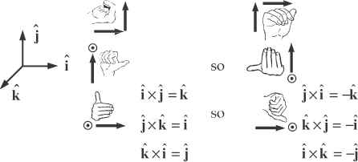P11.4** 

 and  are zero similarly since the vectors being multiplied are parallel.



**ANS. FIG. P11.4**

**P11.5** (a) The lever arms of the forces about *O* are all the same, equal to length *OD*, *L*.

If  has a magnitude  the net torque is zero:



(b) The torque produced by  depends on the perpendicular distance *OD*, therefore translating the point of application of  to any other point along *BC* 

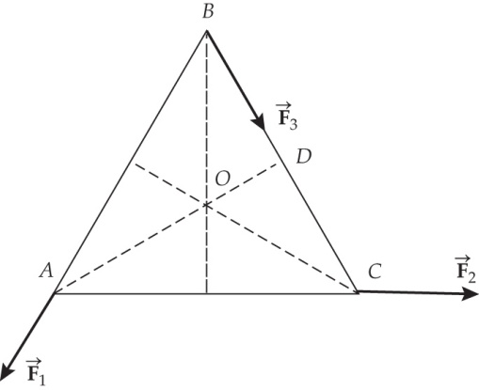

ANS. FIG. P11.5

**P11.6** (a) 

(b) The cross-product vector must be perpendicular to both of the factors, so its dot product with either factor must be zero. To check:



The answer is not zero.



**P11.7** (a) The torque acting on the particle about the origin is



(b) 

(c) 

(d) 

(e) 

(f) Let (0, *y*) represent the coordinates of the special axis of rotation located on the *y* axis of Cartesian coordinates. Then the displacement from this point to the particle feeling the force is  in meters. The torque of the force about this new axis is



Then,



The position vector of the new axis is 

Section 11.2 Analysis Model: Nonisolated System (Angular Momentum)

**P11.8** We use 

****

**P11.9** We use 



**P11.10** Whether we think of the Earth’s surface as curved or flat, we interpret the problem to mean that the plane’s line of flight extended is precisely tangent to the mountain at its peak, and nearly parallel to the wheat field. Let the positive *x* direction be eastward, positive *y* be northward, and positive *z* be vertically upward.

(a) 



(b)   and *r*sin*θ* is the altitude of the plane. Therefore, *L* = *constant* as the plane moves in level flight with constant velocity.

(c)  The position vector from Pike’s Peak to the plane is anti-parallel to the velocity of the plane. That is, it is directed along the same line and opposite in direction. Thus, *L* = *mvr*sin180° = 0.

**P11.11** (a)  because  and ****

(b) At the highest point of the trajectory,

 and



The angular momentum is then



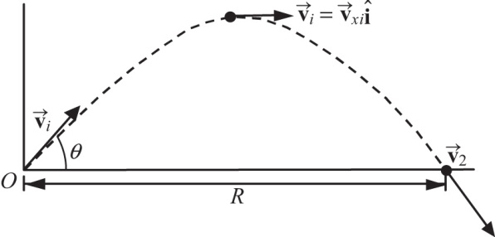

ANS. FIG. P11.11

(c) 

(d) 

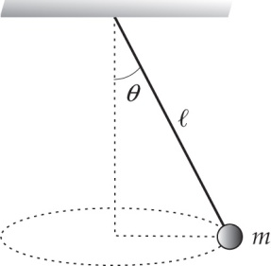**P11.12** We start with the particle under a net force model in the *x* and *y* directions:





**ANS. FIG. P11.12**

So 

then 

and since 



**P11.13** The angular displacement of the particle around the circle is 

The vector from the center of the circle to the mass is then

 where *R* is measured from the +*x* axis.

The vector from point *P* to the mass is



The velocity is



So



**P11.14** (a) 

 in meters, where *t* is in seconds.

(b) 

(c) 

(d) 

(e) 

(f) 

(g) 

(h)  all where *t* is in seconds.

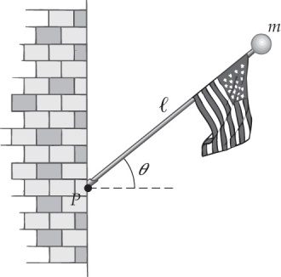**P11.15** (a) The vector from *P* to the falling ball is



The velocity of the ball is

ANS. FIG. P11.15



So 





(b) 

(c) Differentiating with respect to time, we have  for the rate of change of angular momentum, which is also the torque

Section 11.3 Angular Momentum of a Rotating Rigid Object

**P11.16** The moment of inertia of the sphere about an axis through its center is



Therefore, the magnitude of the angular momentum is



Since the sphere rotates counterclockwise about the vertical axis, the angular momentum vector is directed upward in the +*z* direction.

Thus,



due to the gravitational force on the ball.

**P11.17** (a) For an axis of rotation passing through the center of mass, the magnitude of the angular momentum is given by



(b) For a point midway between the center and the rim, we use the parallel-axis theorem to find the moment of inertia about this point. Then,



**P11.18** We begin with



And multiply the right-hand side by 



Substituting  then gives

****

**P11.19** The total angular momentum about the center point is given by



For the hour hand: 

For the minute hand: 

In addition, 

while 

Thus, 

or . The hands turn clockwise, so their vector angular momentum is 

**P11.20** (a) Modeling the Earth as a sphere, we first calculate its moment of inertia about its rotation axis.



Completing one rotation in one day, Earth’s rotational angular speed is



the rotational angular momentum of the Earth is then



The Earth turns toward the east, counterclockwise as seen from above north, so the vector angular momentum points north along the Earth’s axis,  or nearly toward the star Polaris.

(b) In this case, we model the Earth as a particle, with moment of inertia



Completing one orbit in one year, Earth’s orbital angular speed is



the angular momentum of the Earth is then



The Earth plods around the Sun, counterclockwise as seen from above north, so the vector angular momentum points north perpendicular to the plane of the ecliptic,  or 23.5° away from Polaris, toward the center of the circle that the north celestial pole moves in as the equinoxes precess. The north ecliptic pole is in the constellation Draco.

(c) 

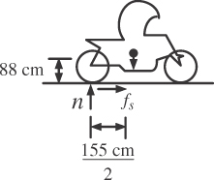**P11.21** We assume that the normal force n = 0 on the front wheel. On the bicycle,



We must use the center of mass as the axis in

**ANS. FIG. P11.21**



*Fg* (0) − *n*(77.5 cm) + *fs* (88 cm) = 0

We combine the equations by substitution:



Section 11.4 Analysis Model: Isolated System (Angular Momentum)

**\*P11.22 Conceptualize** Review Example 11.6 to help understand what happens when the radius of a star changes. Because the neutron star becomes smaller, the angular speed increases, just like for the diver in the chapter-opening photograph.

**Categorize** The neutron star is modeled as an *isolated system* for *angular momentum.*

**Analyze** Begin with the isolated system model for angular momentum for the star, expressed in Equation 11.20:

 (1)

Use Equation 11.16 to substitute for the angular momenta:

 (2)

Use Equation 4.23 to express the angular speed in terms of period:

 (3)

While we are assuming the neutron star is spherical, we don't know about the mass distribution. All we can say is that the moment of inertia can be expressed as *kMR*2, where *k* is a constant that depends on the mass distribution. Incorporate this into Equation (3):

 (4)

Substitute numerical values:



**Finalize** The neutron star has shrunk by 6%. The understanding of the interior of a neutron star is still incomplete. The superfluid vortices mentioned by your supervisor represent one possible model. In 2012, an *anti-glitch* was detected: the period of the neutron star *increased* suddenly. More work needs to be done to completely understand the interior structure of neutron stars.

*Answer:* 9.4 km

**P11.23** (a) 

(b) 

(c) 

(d) From conservation of angular momentum for the system of the woman and the turntable, we have Lf = Li = 0,

so, 

and 



or 

(e) Chemical energy converted into mechanical energy is equal to





**P11.24** (a) Angular momentum is conserved in the puck-rod-putty system because there is no net external torque acting on the system.







Solving for the final velocity gives



Then,



(b) 

(c) 

(d) 

**P11.25** (a) We solve by using conservation of angular momentum for the turntable-clay system, which is isolated from outside torques:



Solving for the final angular velocity gives



(b)  The initial energy is



The final mechanical energy is



Thus 507 J of mechanical energy is transformed into internal energy. The “angular collision” is completely inelastic.

(c) No. The original horizontal momentum is zero. As soon as the clay has stopped skidding on the turntable, the final momentum is (2.25 kg)(1.80 m)(11.1 rad/s) = 44.9 kg · m/s north. This is the amount of impulse injected by the bearing. The bearing thereafter keeps changing the system momentum to change the direction of the motion of the clay. The turntable bearing promptly imparts an impulse of 44.9 kg · m/s north into the turntable-clay system, and thereafter keeps changing the system momentum.

**P11.26** When they touch, the center of mass is distant from the center of the larger puck by



(a) 

(b) The moment of inertia about the CM is



Angular momentum of the two-puck system is conserved:





**P11.27** (a) Taking the origin at the pivot point, note that  is perpendicular to  so sin = 1 and  vertically down.

(b) Taking *vf* to be the speed of the bullet and the block together, we first apply conservation of angular momentum: *Li* = *Lf* becomes



The total kinetic energies before and after the collision are, respectively,

**

and 

So the fraction of the kinetic energy that is converted into internal energy will be



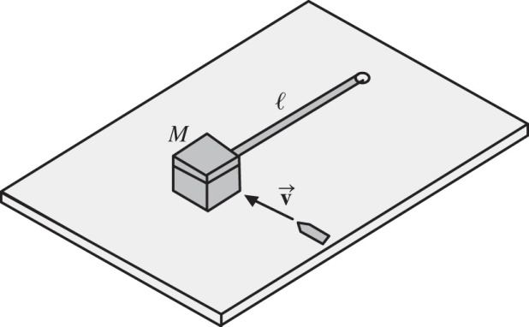

ANS. FIG. P11.27

**P11.28** The rotation rate of the station is such that at its rim the centripetal acceleration, *ac*, is equal to the acceleration of gravity on the Earth’s surface, *g*. Thus, the normal force from the rim’s floor provides centripetal force on any person equal to that person’s weight:



The space station is isolated, so its angular momentum is conserved. When the people move to the center, the station’s moment of inertia decreases, its angular speed increases, and the effective value of gravity increases.

From angular momentum conservation: , where





The centripetal acceleration is the effective value of gravity:  Comparing values of acceleration before and during the union meeting, we have





**P11.29** (a) Consider the system to consist of the wad of clay and the cylinder. No external forces acting on this system have a torque about the center of the cylinder. Thus, angular momentum of the system is conserved about the axis of the cylinder.

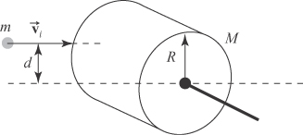

**ANS. FIG. P11.29**

Lf = Li: 

or 

Thus, 

(b) 

(c) 

**P11.30** (a)  the bullet has angular momentum about an axis through the hinges of the door before the collision.

(b) The bullet strikes the door

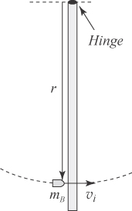 *r* = 1.00 m – 0.100 m = 0.900 m

from the hinge. Its initial angular momentum   
is therefore



ANS. FIG. P11.30

(c) 

(d) Apply conservation of angular momentum, 



where *L* = 1.00 m = the width of the door and *r* = 0.900 m [from part (b)]. Solving for the final angular velocity gives,



(e) The kinetic energy of the door-bullet system immediately after impact is



The kinetic energy (of the bullet) just before impact was



The total energy of the system must be the same before and after the collision, assuming we ignore the energy leaving by mechanical waves (sound) and heat (from the newly-warmer door to the cooler air). The kinetic energies are as follows: 



Section 11.5 The Motion of Gyroscopes and Tops

**P11.31** We begin by calculating the moment of inertia of the Earth, modeled as a sphere:

****

Earth’s rotational angular momentum is then



from which we can calculate the torque that is causing the precession:



**Additional Problems**

**P11.32** (a) Assuming the rope is massless, the tension is the same on both sides of the pulley:

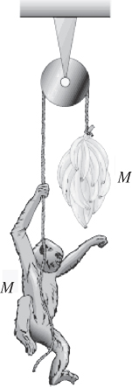

ANS. FIG. P11.32



(b)  and since  *L* = constant.

Since the total angular momentum of the system is initially zero, the total angular momentum remains zero, so the   at any instant.

(c)  The motions of the monkey and bananas are identical, so the bananas remain out of the monkey’s reach—until they get tangled in the pulley. To state the evidence differently, the tension in the rope is the same on both sides. Newton’s second law applied to the monkey and bananas give the same acceleration upward.

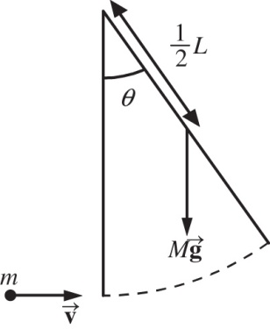**P11.33** (a) Let *ω* be the angular speed of the signboard   
when it is vertical.





**ANS. FIG. P11.33**

(b)  represents angular momentum conservation for the sign-snowball system. Substituting into the above equation,



Solving,



(c) Let  distance of center of mass from the axis of rotation.



Applying conservation of mechanical energy,



Solving for  then gives



**\*P11.34 Conceptualize** Look online for videos of people doing flips on trampolines. Do *not* try to perform flips yourself unless you have practiced extensively.

**Categorize** The center of mass of the student is a *particle under constant acceleration* once he leaves the trampoline mat. The body of the student is an *isolated system* for *angular momentum* for the entire time interval that he is in the air.

**Analyze**  First, consider the free-fall motion of his center of mass. Write Equation 4.17:

 (1)

Let the initial point be as his feet leave the trampoline mat, and let the final point be just as he comes to rest momentarily at the top of his motion. Then

 (2)

This result provides the speed with which he must leave the trampoline mat to raise his center of mass by a height *h*. Now, use Equation 4.13 to find the time at which he reaches the highest point:

 (3)

The total time interval in the air is twice this value:

 (4)

If we subtract the time intervals at the beginning and the end when his body is straight, we will have the time interval during which he is in a tuck position and doing flips:

 (5)

Now, let’s look at the conservation of angular momentum while he is in the air. Conservation of angular momentum gives us

 (6)

Express the angular speed on the right side in terms of the period of rotation and solve for the period:

 (7)

The number of flips he can do while tucked will be the total time interval for the flips, Equation (5), divided by the time interval per flip, Equation (7):

 (8)

Substitute numerical values:



This is the number of flips he can do in the tuck position. He is also rotating in the straight position at 2.88 rad/s for a total time interval of 0.400 s before going into the tuck position plus 0.400 s after he straightens out again. Therefore, the number of flips he can do while straightened out is



The total number of flips while in the air is



Finalize If he performed this many flips, he would end up landing on the trampoline surface on his head. You don't want him to do that. You should suggest that your fellow student modify his jump a little so that he should be able to perform three flips. Of course, that will require a great deal of practice, not only to do the flips, but also to come out of the tuck position and land safely.

*Answer:* three

**P11.35** First, we define the following symbols:

*IP* = moment of inertia due to mass of people on the equator

*IE* = moment of inertia of the Earth alone (without people)

*ω* = angular velocity of the Earth (due to rotation on its axis)

 rotational period of the Earth (length of the day)

*R* = radius of the Earth

The initial angular momentum of the system (before people start running) is



When the Earth has angular speed *ω*, the tangential speed of a point on the equator is  Thus, when the people run eastward along the equator at speed *v* relative to the surface of the Earth, their tangential speed is  and their angular speed is



The angular momentum of the system after the people begin to run is



Since no external torques have acted on the system, angular momentum is conserved  giving



Thus, the final angular velocity of the Earth is

 where 

The new length of the day is



so the increase in the length of the day is



Since  this may be written as



To obtain a numeric answer, we compute



and



Thus,



**P11.36** The description of the problem allows us to assume the asteroid-Earth system is isolated, so angular momentum is conserved (). Let the period of rotation of Earth be *T* before the collision and  after the collision. We have



which gives



Treating Earth as a solid sphere of mass *M* and radius *R*, its moment of inertia is  The moment of inertia of the asteroid at the equator is *mR*2. We have then





**P11.37** (a) The moment of inertia is given by



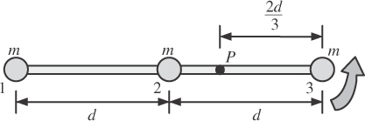

ANS. FIG. P11.37

(b) Think of the whole weight, 3*mg*, acting at the center of gravity.



(c) We find the angular acceleration from



(d) The linear acceleration of particle 3, a distance of 2*d*/3 from the pivot, is



(e) Because the axle is fixed, no external work is performed on the system of the Earth and the three particles, so total mechanical energy is conserved. Rotational kinetic energy will be maximum when the rod has swung to a vertical orientation with the center of gravity directly under the axle. Take gravitational potential energy to be zero when the rod is in its vertical orientation. In the initial horizontal orientation, the center of gravity of the system will be *d*/3 higher:



(f) In the vertical orientation, the rod has the greatest rotational kinetic energy:



(g) The maximum angular momentum of the system is



(h) The maximum speed of particle 2 is



**P11.38** (a) Momentum is conserved in the isolated system of the two boys:





(b) The initial kinetic energy of the system is



and the kinetic energy after the collision is



Thus the fraction remaining is



(c) The calculation in part (a) still applies: 

(d) Taking Jacob (*m*1 = 45.0 kg) at the origin of a coordinate system, with Ethan (*m*2 = 31.0 kg) on the *y* axis at *y* = *L* = 1.20 m, the position of the CM of the boys is



Jacob is *y*CM = 0.489 m from the CM and Ethan is  =  from the CM. Their angular momentum about the CM is 

**



(e) Their kinetic energy after they link arms is



[Note: the result of the calculation of kinetic energy is exactly   
3 315.5 J if no round-off is made in the calculation. It can be shown algebraically that the expression for the final kinetic energy is equivalent to the expression for the initial kinetic energy—the student is invited to show this.] Thus the fraction remaining is 

(f) 

**P11.39** Both astronauts will speed up equally as angular momentum for the two-astronaut-rope system is conserved in the absence of external torques. We use this principle to find the new angular speed with the shorter tether. Standard equations will tell us the original amount of angular momentum and the original and final amounts of kinetic energy. Then the kinetic energy difference is the work.

(a) The angular momentum magnitude is  In this case,  are perpendicular, so the magnitude of *L*about the center of mass is

**

(b) The original kinetic energy is

**

(c) With a lever arm of zero, the rope tension generates no torque about the center of mass. Thus, the angular momentum for the two-astronaut-rope system is unchanged:



(d) Again, *L* = 2*mrv,* so



(e) The final kinetic energy is



**P11.40** Please refer to ANS. FIG. P11.40 and the discussion in P11.40 above.

(a) 

(b) 

(c) 

(d) 

(e) 

(f) If the work performed by the astronaut is made possible entirely by the conversion of chemical energy to mechanical energy, then the necessary chemical potential energy is:



**P11.41** (a) At the moment of release, two stones are moving with speed *v*0. The total momentum has magnitude  It keeps this same horizontal component of momentum as it flies away.

(b) The center of mass speed relative to the hunter is *v*CM = *p*/*M* = 2*mv*0/3*m* =  before the hunter lets go and, as far as horizontal motion is concerned, afterward.

(c) When the bola is first released, the stones are horizontally in line with two at distance  on one side of the center knot and one at distance  on the other side. The center of mass (CM) is then   
 from the center knot closer to the two stones: the one stone just being released is at distance  from the CM, the other two stones are at distance  from the CM.

The two stones, moving at *v*0, have a relative speed *v*2 = *v*0 – 2*v*0/3 = *v*0/3 with respect to the CM, and the one stone has relative speed *v*1 = 2*v*0/3 – 0 = 2*v*0/3 with respect to the CM. The one stone has angular speed



The other two stones have angular speed



which is necessarily the same as that of stone 1:  The total angular momentum around the center of mass is



The angular momentum remains constant with this value as the bola flies away.

(d) As computed in part (c), the angular speed *ω* at the moment of release is ** As it moves through the air, the bola keeps constant angular momentum, but its moment of inertia changes to  Then the new angular speed is given by



(e) At the moment of release,



(f) As it flies off in its horizontal motion it has kinetic energy



(g) 

**P11.42** (a) The equation simplifies to



which gives



(b) 

(c) 

(f) The energy converted by the astronaut is the work he does:

**

**\*P11.43 Conceptualize** Figure P11.43 shows the physical setup of the carnival game. When the ball collides with the lower end of the rod and sticks to it, the rod–ball combination will rotate counterclockwise. The goal is to have the rod reach a position 180° opposite to where it begins.

**Categorize** The collision of the ball and the rod can be analyzed with the *isolated system* model for *angular momentum*. After the collision, the *isolated system* model for *energy* can be used to analyze the swinging upward of the combined rod and stick.

**Analyze** Assume the ball strikes the rod at its lower end, as suggested by your friend in the problem description. Apply the isolated system model for angular momentum to the ball–rod system, with the initial instant just before the collision and the final instant just after, and taking all angular momenta around the pivot point of the rod:

 (1)

where ** is the angular speed of the system just after the collision. Apply the isolated system model for energy to the ball–rod system, with the initial instant just after the collision and the final instant as the rod reaches its highest vertical position and just comes to rest. This choice will provide the minimum speed with which the ball must have been thrown initially.



where we have defined the configuration of the system just after the collision, with the rod hanging straight down, as the reference configuration for gravitational potential energy, with a value of zero, and have recognized that the center of mass of the rod rises by a distance equal to the length of the rod, and the ball rises twice that distance. Solve Equation (1) for the ball speed *v* and substitute for the angular speed ** from Equation (2). Simplifying, we find

 (3)

Substituting numerical values,



Finalize It is difficult for some people to throw a 1.00-kg ball at this speed, especially with enough accuracy to strike the rod *and* at the desired point on the rod.

*Answer:* 10.7 m/s

**P11.44** (a) Let *M* = mass of rod and *m* = mass of each bead. From  between the moment of release and the moment the beads slide off, we have



When *M* = 0.300 kg, , *r*1 = 0.100 m, *r*2 = 0.250 m, and  
*ωi* = 36.0 rad/s, we find





(b) The denominator of this fraction always exceeds the numerator, so

****

**P11.45** The moment of inertia of the rest of the Earth is



For the original ice disks,



For the final thin shell of water,



Conservation of angular momentum for the spinning planet is expressed by 



**P11.46** To evaluate the change in kinetic energy of the puck, we first calculate the initial and final moments of inertia of the puck:

**:Art:Chapter 10 art:P10_51.eps** 

and



ANS. Fig. P11.46

The initial angular velocity of the puck is given by



Now, use conservation of angular momentum for the system of the puck,



Now,



**\*P11.47 Conceptualize** Imagine stepping off of a wagon onto the floor. You go forward and the wagon goes backward: conservation of linear momentum. A similar thing happens here due to conservation of *angular* momentum: the train rotates one way, and the Lazy Susan, along with the flower arrangement, turns the other way! Beautiful!

**Categorize** The train and Lazy Susan are modeled as an *isolated system* for *angular momentum.*

**Analyze** Begin with the isolated system model for angular momentum, expressed in Equations 11.19 and 11.20:

 (1)

The initial angular momentum, before you power the train, is zero. After you push the button so that the train begins moving, the final angular momentum is that of the train plus that of the Lazy Susan:

 (2)

Replace each angular momentum with *I*:

 (3)

These angular speeds are measured with respect to the Earth. Evaluate the moments of inertia:

 (4)

Solve for the angular speed of the loaded train:

 (5)

Substitute numerical values:



Therefore, the train and the Lazy Susan both rotate at the same angular speed, but in opposite directions! If the flatcar begins at a certain point marked on the Lazy Susan, the flatcar and that mark will be together again for the first time after the train has gone 180° around a circle relative to the Earth. Relative to the track, the train must travel the *entire* circumference of the track at this time, starting at the mark and ending at the mark. Therefore, the time interval required to deliver the salt and pepper is



Finalize This is a rather long time interval, compared to passing it around the table, person to person, or putting it on the original Lazy Susan and rotating it with your hand. Is this long time interval worth the uniqueness of the train setup and the rotating flowers? Notice that the delivery time will depend on what mass is loaded onto the train. If a very heavy mass is loaded onto the train (bread basket, ketchup, water bottles), the angular speed of the train could be much smaller than that of the Lazy Susan. As a result, the Lazy Susan could make many rotations before the train finally chugs its load to the other side of the table!

Answer: 14.0 s

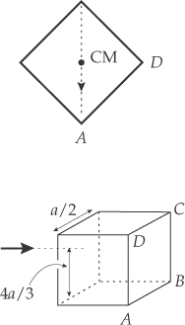Challenge Problems

**P11.48** For the cube to tip over, the center of mass (CM)   
must rise so that it is over the axis of rotation *AB*.   
To do this, the CM must be raised a distance of   
 After the bullet strikes the cube, the   
system is isolated:

ANS. FIG. P11.48



The moment of inertia of the cube about its CM (from Table 10.2) is



The cube rotates about an edge,  from the CM. By the parallel-axis theorem,



From conservation of angular momentum,



Inserting the expression for *ω* back into the energy equation, we have



**P11.49** (a) After impact, the disk adheres to the stick, so they will rotate about their common center of mass; therefore, we must consider the angular momentum of the system about its CM. First we find the velocity of the CM by writing the equations for momentum conservation:



The speed of the CM is 

(b) Locate the center of mass between the disk and the center of the stick at impact:



This means at impact the CM is 4/3 meters from the center of the stick; therefore, the disk is 2.0 meters – 4/3 meters = 2/3 meters from the CM at impact. Use the parallel-axis theorem to find the moment of inertia of the system about the CM:



The moment of inertia of the disk about the CM is



Angular momentum about the CM is conserved:



**P11.50** Angular momentum is conserved during the inelastic collision.



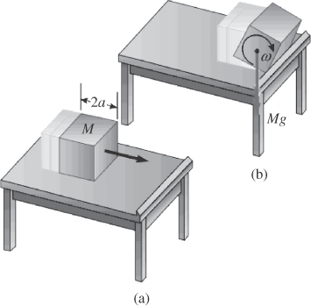

ANS. FIG. P11.50

The condition, that the box falls off the table, is that the center of mass must reach its maximum height as the box rotates,  Using conservation of energy:





|  |
| --- |
| **ANSWERS TO QUICK-QUIZZES** |

**1.** (d)

**2. (i)** (a) **(ii)** (c)

**3.** (b)

**4.** (a)

|  |
| --- |
| **ANSWERS TO EVEN-NUMBERED PROBLEMS** |

**P11.2** (a) 740 cm2; (b) 59.5 cm

**P11.4** See full solution in P11.4.

**P11.6** (a) No; (b) No, the cross product could not work out that way.

**P11.8** 

**P11.10** (a) ; (b) No; (c) Zero

**P11.12** 

**P11.14** (a) ; (b) The particle starts from rest at the origin, starts moving into the first quadrant, and gains speed faster while turning to move more nearly parallel to the x axis; (c)    
(d)  (e) ; (f)    
(g) (90*t*4 + 10*t*2) J; (h) (360*t*3 + 20*t*) W

**P11.16** 

**P11.18** 

**P11.20** (a) , toward the north celestial pole;   
(b) , toward the north ecliptic pole; (c) See P11.20 (c) for full explanation.

**P11.22** 9.4 km

**P11.24** (a) 2.91 s; (b) Yes because there is no net external torque acting on the puck-rod-putty system; (c) No because the pivot pin is always pulling on the rod to change the direction of the momentum; (d) No. Some mechanical energy is converted into internal energy. The collision is perfectly inelastic.

**P11.26** (a) ; (b) 9.47 rad/s

**P11.28** When the people move to the center, the angular speed of the station increases. This increases the effective gravity by 26%. Therefore, the ball will not take the same amount of time to drop.

**P11.30** (a) yes (b) 4.50 kg ? m2/s (c) No. In the perfectly inelastic collision, kinetic energy is transformed to internal energy. (d) 0.749 rad/s (e) The total energy of the system *must* be the same before and after the collision, assuming we ignore the energy leaving by mechanical waves (sound) and heat (from the newly-warmer door to the cooler air). The kinetic energies are as follows: *Ki* 5 2.50 3 103 J; *Kf* 5 1.69 J. Most of the initial kinetic energy is transformed to internal energy in the collision**.**

**P11.32** (a)

(b) at any instant. (c) 

**P11.34** Three

**P11.36** An asteroid that would cause a 0.500-s change in the rotation period of the Earth has a mass of 1.38 × 1019 kg and is an order of magnitude larger in diameter than the one that caused the extinction of the dinosaurs.

**P11.36** (a) ; (b) 0.000 716; (c)  (d) 15.8 rad/s; (e) 1.00;   
(f) See P11.36 (f) for full explanation.

**P11.38** (a) Mvd; (b) *Mv*2; (c) Mvd; (d) 2v; (e) 4*Mv*2; (f) 3*Mv*2

**P11.40** (a)  (b) See P11.40 (b) for full problem statement; (c) Yes, with the left-hand side representing the final situation and the right-hand side representing the original situation, the equation describes the throwing process.

**P11.42** (a) 4.50 m/s; (b) 10.1 N; (c) 0.450 J

**P11.44** (a)  (b) *ωf* decreases smoothly from a maximum value of 36.0 rad/s for m = 0 toward a minimum value of (36 × 3.2/20) = 5.76 rad/s as 

**P11.46** **

**P11.48** 

**P11.50 4 $\sqrt{\frac{13}{}ga(\sqrt{2}-1)}$**